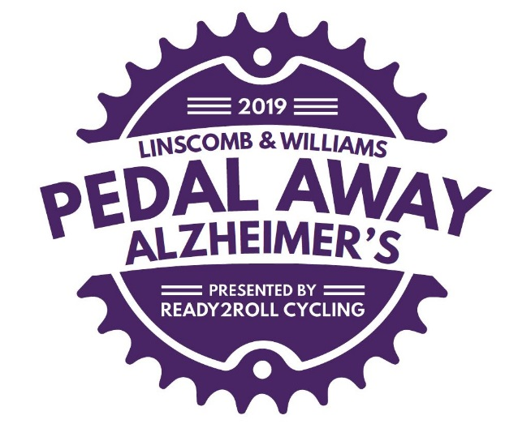

About The Ride

As the presenting sponsor, we at Ready2Roll Cycling (Steve and Robbie Moskowitz and Marshall and Jan Cohen) have been directly affected by Alzheimer’s and are fully aware that many of our fellow riders have been too. Over the years we have helped cyclists get in better shape, become better cycling advocates and raise awareness and millions of dollars for Multiple Sclerosis (MS). With our leadership, influence, and experience, in addition to MS, our desire was to help do the same for Alzheimer’s.

We decided that we wanted to use our expertise and organize a bike ride that would raise awareness and funds to help fight this horrible disease. As the leaders of the Ready2Roll Cycling fully supported cycling training series, we definitely know how to organize bike rides. For the past 25 years, we have been offering a fully-supported 12-14 week training series to help riders prepare for the BP MS 150 and other cycling events with 1,700 enrolled riders last year alone. Our exposure in the cycling community has been significant and we thought that if we reached out to this community offering a new ride that benefits Alzheimer’s, the community would respond. And yes they have, as the response has been overwhelming with 762 riders in 2017 (two weeks after Hurricane Harvey), 1,200 in 2018 and an expected 1,500 in 2019. Best of all, we have already made a significant impact with the Alzheimer’s Association as the event is growing.

When we began building out the concept for this event back in 2017, we decided that we wanted to offer various routes that were on beautiful, quiet roads, with a few challenging hills and a welcoming community. We also said that we wanted to host a fun-filled post ride party with great sponsors. Fortunately, we identified the Austin County Fairgrounds in Bellville for the start/finish with cycling routes through Cat Spring and New Ulm that are about as good as it gets.

The Austin County Fairgrounds is an ideal location to host the start and finish given the expansive grounds for parking, the covered pavilion for packet pickup and the post ride party, and the hospitality by the management team for the Fairgrounds.

With this new event, we needed important sponsors that were committed to be part of the ride and could help deliver an exceptional experience for the participants. Proudly, we have secured extremely gracious and generous sponsors that not only believe in the cause against Alzheimer’s, but see a great connection to be an integral part of the cycling community. We can only hope our participants engage our sponsors which will further deliver the value of their participation.

To put on the Linscomb & Williams Pedal Away Alzheimer’s ride requires a large number of volunteers that are willing to give up their valuable time to support the ride. We never underestimate the value of the volunteers and of course, the participants sincerely appreciate all the support. Without amazing volunteers like we have, the event simply cannot happen so we are grateful for all they do.

So, we hope that you now have a better understanding about the ride and how we got here, but more importantly, hope that you will reach out to your own community and ask that they be part of this growing event by riding, volunteering or even sponsoring. Thank you for your generous support in the fight against Alzheimer’s.

