Holland House
24 N Holland
Bellville, Texas 77418
713-816-6980

Best Western Inn of Brenham
1503 Hwy. 290 E.
Brenham, Texas 77833
979-251-7791
(979) 251-7791
Bader B & B
28 N Cummings St
Bellville, TX 77418
979-885-9526(9
Eberly Ranch
10430 Eberly Ranch Rd
Chappell Hill, TX 77426
713-875-6738
713) 875-6738
Grace Cottage
104 Lee Lane
Bellville, TX 77418
713-594-5556
(713) 594-5556
Somewhere in Time Bed & Breakfast
1034 S Tesch
Bellville, TX 77418
979-865-9547
(979) 865-9547
Blisswood Bed, Breakfast & Spa
13251 Newberg Rd
Cat Spring, TX 78933
713-301-3235301-3235

Texas Ranch Life
10899 Cactus Ln
Chappell Hill, TX 77426
979-865-3649979) 865-3649
Dove Cottage B & B
519 S Masonic
Bellville, TX 77418-2519
979-865-9360

Magnolia Hideaway NEW!
152 Lynn Rd
Bellville, TX 77418
713-240-8950

Mockingbird Landing NEW!
508 E Austin St
Bellville, TX 77418
713-628-0999

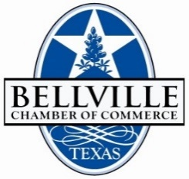

Revised071819

